Multifunctional Photoresponsive System Focused on Molecular Orbital Topology and Molecular Alignment
タイトル氏名12pt Times (Times New Roman) bold 行間14pt
タイトルはofficialの英語課題名（領域Webに記載済み）
分担者は記載するが、連携者は記載しない。
A4 １ページ
余白は上下左右25 mm
A02 Kenji Matsuda (Kyoto Univ.)
分担者がいる場合は下の行に書く→
Xxxxx Yyyyy (Zzzzz Univ.)
kmatsuda@sbchem.kyoto-u.ac.jp
研究代表者メールアドレス→

In order to apply photochromic diarylethene in practical use, especially in molecular electronics, assembly and arrangement of the molecules are very important. Therefore, supramolecular chemistry in two- and three dimensional assemblies is attracting interest. Two-dimensional (2D) self-assembly of photochromic diarylethenes were studied by STM at a liquid/solid interface at the single molecule resolution [1-5]. The concentration dependence of surface coverage of 1o-C16 showed abrupt increase at certain concentration, but no ordering was observed for the closed-ring isomer 1c-C16 at various concentrations (Figure 1a,b) [1]. The adsorption behavior was explained by a cooperative self-assembly model with the nucleation and elongation constants K_{n} and K_{e}, which has been originally developed by our group. Highly sensitive system can be designed by using high cooperativity.
We have further investigated the relationship between molecular structure and cooperativity [4]. The critical concentration, at which a stable 2D molecular ordering appears, exponentially decreases with increasing length of the alkyl chain (Figure 1c). Compounds bearing amide groups (1o) have higher degrees of cooperativity than compounds with ester groups (2o). The self-assembly process of the open-ring isomer of an ester derivative (2o) is close to isodesmic, whereas that of the closed-ring isomer (2c) is cooperative. These findings would enable precise control of cooperativity in self-assembly on 2-D surfaces and give rise to the sophisticated photoresponsive system.
カラー可
本文、11 pt 行間14pt

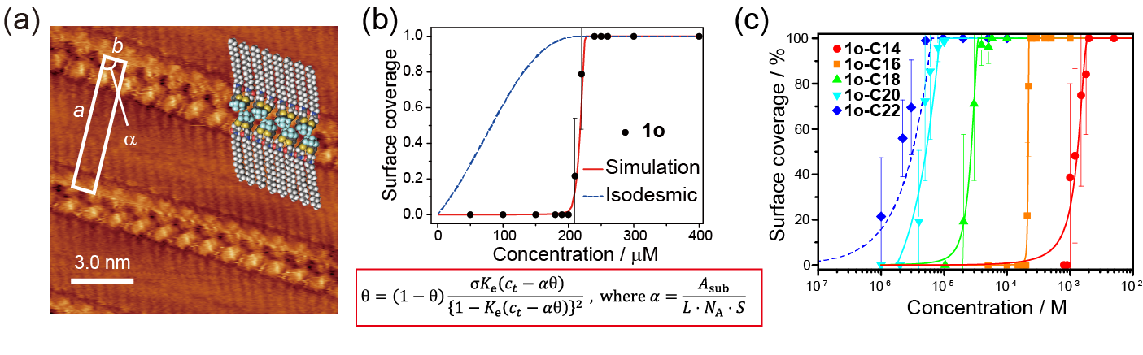

Figure 1. a) High-resolution STM images of 1o-C16 measured at an octanoic acid/HOPG interface.
b) Concentration dependence of surface coverage of 1o-C16 and the equation used for the simulation.
c) Concentration dependence of surface coverage of 1o-Cn series.

References
1. S. Yokoyama, T. Hirose, K. Matsuda, Chem. Commun. 2014, 50, 5964-5966. (back cover)
2. D. Frath, T. Sakano, Y. Imaizumi, S. Yokoyama, T. Hirose, K. Matsuda, Chem. Eur. J. 2015, 21, 11350-11358. (frontispiece)
3. N. Nishitani, T. Hirose, K. Matsuda, Chem. Asian J. 2015, 10, 1926-1931. (front cover and VIP, highlighted in ChemistryViews July 11, 2015)
4. S. Yokoyama, T. Hirose, K. Matsuda, Chem. Eur. J. 2015, 21, 13569-13576. (front cover and Hot Paper)
5. N. Maeda, T. Hirose, S. Yokoyama, K. Matsuda, J. Phys. Chem. C 2016, on the web.

